**BeatBard – A Discord Bot**

**MAJOR PROJECT-I**

**(20SSP47)**

Submitted by

**Karthik Chockalingam V**

**20MSS017**

Under the Guidance of

**Dr. G. S. KARTHICK., M.Sc., DCM., NET., Ph.D.,**

Assistant Professor

Department of Software Systems

In partial fulfillment of the requirements for the award of the degree of

**MASTER OF SCIENCE IN SOFTWARE SYSTEMS**

(Five-Years Integrated Programme)

of Bharathiar University

 

**DEPARTMENT OF SOFTWARE SYSTEMS**

**PSG COLLEGE OF ARTS & SCIENCE**

An Autonomous college – Affiliated to Bharathiar University

Accredited with ‘A++’grade by NAAC (4th Cycle)

College with Potential for Excellence

(Status Awarded by the UGC)

Star College Status Awarded by DBT – MST

An ISO 9001:2015 Certified Institution

Coimbatore – 641 014

**November 2023**

**DEPARTMENT OF SOFTWARE SYSTEMS**

**PSG COLLEGE OF ARTS & SCIENCE**

An Autonomous college – Affiliated to Bharathiar University

Accredited with ‘A++’grade by NAAC (4th Cycle)

College with Potential for Excellence

(Status Awarded by the UGC)

Star College Status Awarded by DBT – MST

An ISO 9001:2015 Certified Institution

Coimbatore – 641 014

**CERTIFICATE**

This is to certify that this project work entitled **“BeatBard – A Discord Bot”** is a bonafide record of work done by **Karthik Chockalingam V (20MSS017)** in partial fulfillment of the requirements for the award of Degree of **Master of Science in Software Systems** (Five years Integrated Course) of Bharathiar University.

Faculty Guide Head of the Department

###### Submitted for Viva-Voce Examination held on ____________________.

Internal Examiner External Examiner

**DECLARATION**

I, **KARTHIK CHOCKALINGAM V (20MSS017)**, hereby declare that this project work entitled **“BeatBard – A Discord Bot”** is submitted to PSG College of Arts &Science, Coimbatore in partial fulfillment of the requirements for the award of the degree of Master of Science in Software Systems, is a record of original work done by me under the supervision and guidance of **Dr. G. S. KARTHICK., M.Sc., DCM., NET., Ph.D,** Assistant Professor, Department of Software Systems, PSG College of Arts &Science, Coimbatore.

This report has not been submitted by me for the award of any other Degree/ Diploma/ Associate ship/ Fellowship or any other similar degree to any other university.

**Place: Coimbatore Karthik Chockalingam V**

**Date: (20MSS017)**

**ACKNOWLEDGEMENT**

My venture stands imperfect without dedicating my gratitude to a few people who have contributed a lot towards the victorious completion for my project work.

I would like to thank **Thiru L. Gopalakrishnan, Managing Trustee, PSG & Sons Charities**, for providing me a prospect and surroundings that made the work possible.

I take this opportunity to express my deep sense of gratitude to **Dr. T. Kannaian, M.Tech., Ph.D.,** Secretary, PSG College of Arts & Science, Coimbatore for permitting and doing the needful towards the successful completion of this project.

I express my deep sense of gratitude and sincere thanks to our Principal **Dr. D. Brindha M.Sc., M.Phil., Ph.D.**, **MA (Yoga).,** for her valuable advice and concern on students.

I am very thankful to **Dr. A. Anguraj, M.Sc., M.Phil., Ph.D**., Vice Principal (Academics), **Dr. M. Jayanthi M.Com., MBA., M.Phil., Ph.D.,** Vice Principal (Student Affairs), **Dr. M Umarani, M.B.A., M.Phil., Ph.D.**, Vice Principal (Student Affairs), for their support towards my project.

I sincerely thank **Dr. K. V. Rukmani., MCA., M.E., Ph.D.,** Head of the Department, Department of Software Systems for her whole hearted help to complete this project successfully by giving valuable suggestions.

I convey my heartiest and passionate sense of thankfulness to my project guide **Dr. G. S. KARTHICK., M.Sc., DCM., NET., Ph.D., Assistant Professor**, Department of Software Systems, for her timely suggestion which enabled me in completing the project successfully.

I am grateful to **Mr. Antony Innocent, MCA.,Senior Associate, Aggrandize Venture, External Guide,** for giving me an expert’s insight into the project and for sparing time in her hectic agenda, for planning and giving me invaluable guidance and suggestions

This note of acknowledgement will be incomplete without paying my heartful devotion to my parents, my friends and other people, for their blessings, encouragement, financial support and the patience, without which it would have been impossible for me to complete the job.

**KARTHIK CHOCKALINGAM V**

**20MSS017**

**INTERNSHIP OFFER LETTER**

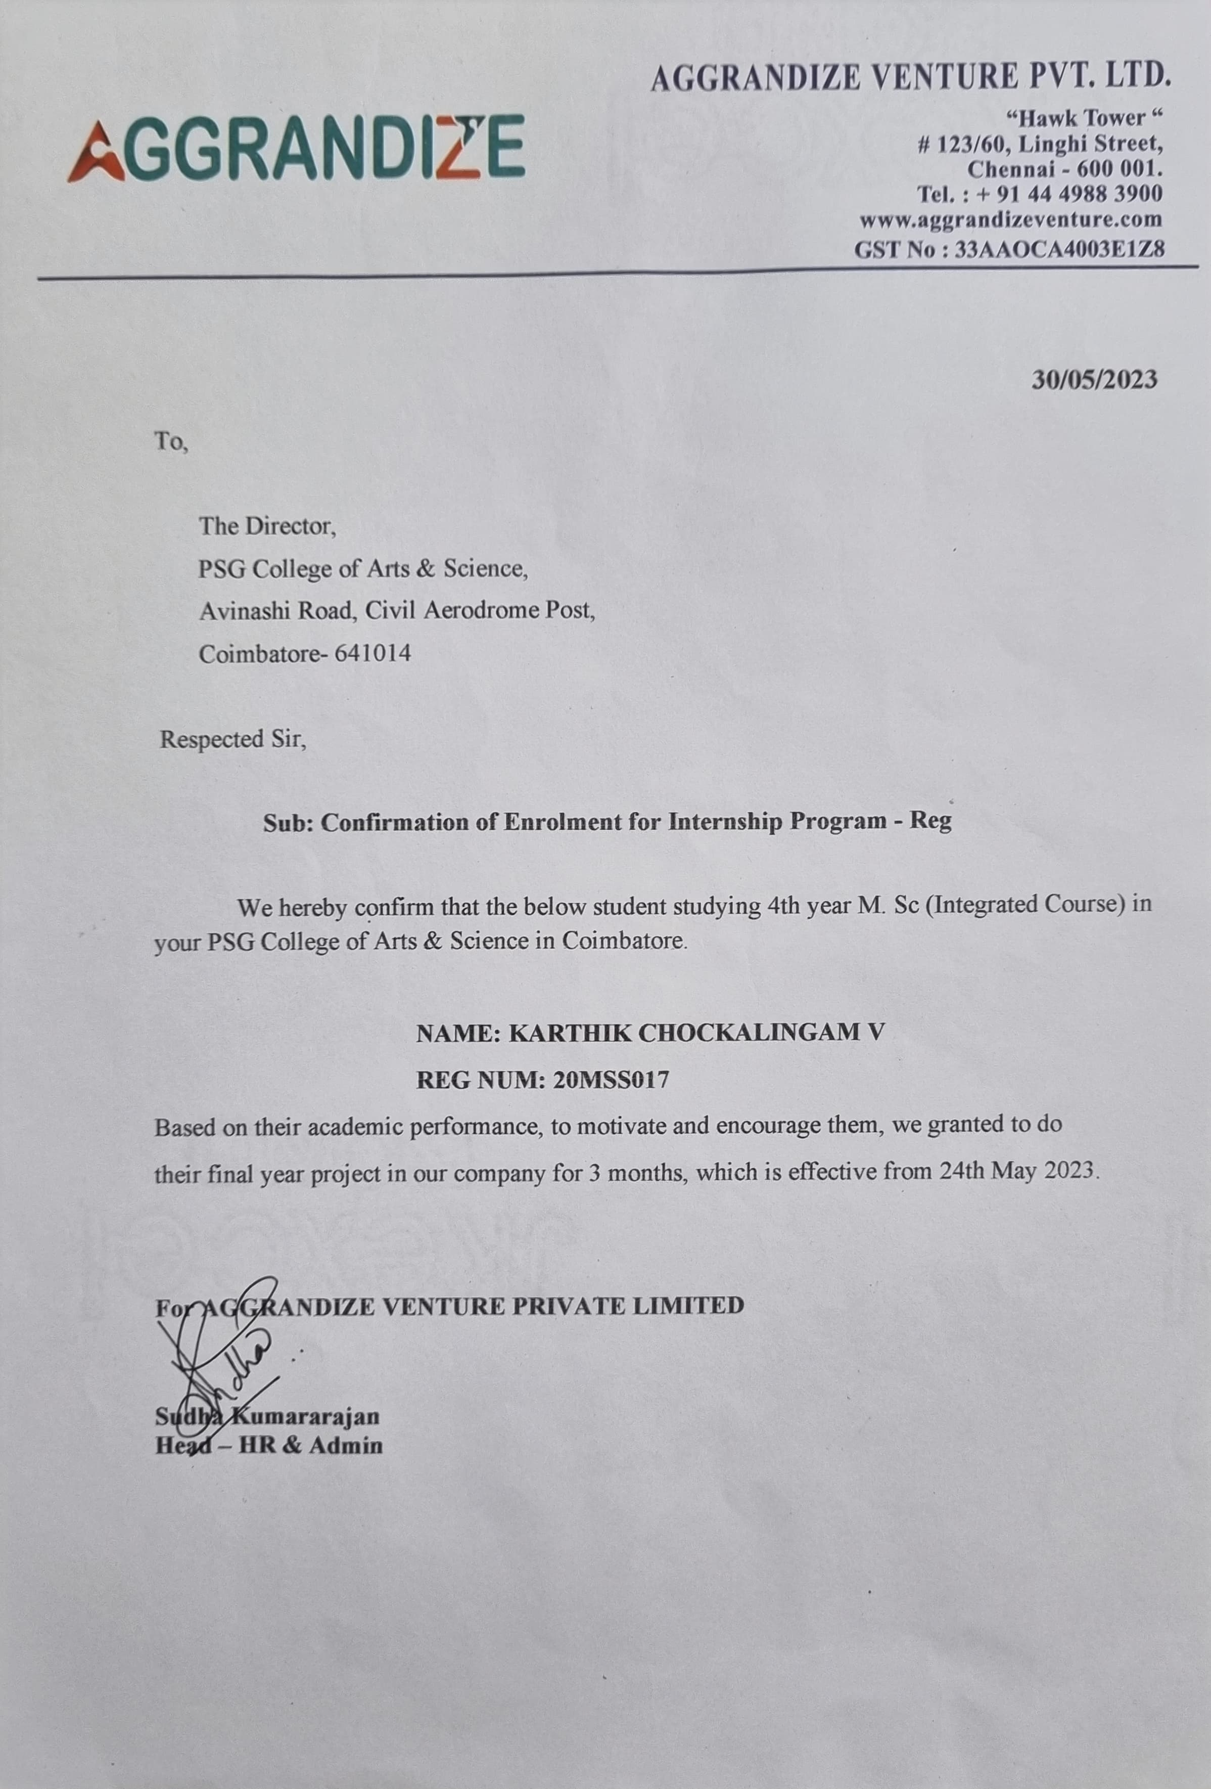

**INTERNSHIP COMPLETION LETTER**

**SYNPOSIS**

**BeatBard - A Discord Bot** is an automated bot entailed for augmenting user experience and analytics on an instant messaging and VoIP social network. The Bot's primary objective is to foster greater engagement with the community and track trends.

The bot will employ the discord.py package, which provides a basic interface for interacting with Discord's Application Interface. The Bot is built using the Discord Developer Portal. The bot creation process comprises the development of a new bot token that is distinctive and unique to each one, in addition to the initial configuration of permissions.

**TABLE OF CONTENTS**

|  |  |  |
| --- | --- | --- |
| **S.No** | **CONTENTS** | **PAGE NO** |
| **1** | **INTRODUCTION** |  |
|  | 1.1 Project Overview |  |
|  | 1.2 Module Description |  |
| **2** | **SYSTEM ANALYSIS** |  |
|  | 2.1 Existing System |  |
|  | 2.2 Proposed System |  |
| **3** | **SYSTEM CONFIGURATION** |  |
|  | 3.1 Hardware Specification |  |
|  | 3.2 Software Specification |  |
| **4** | **SOFTWARE DESCRIPTION** |  |
|  | 4.1 Front End |  |
|  | 4.2 Back End |  |
| **5** | **SYSTEM DESIGN** |  |
|  | 5.1 System Flow Diagram |  |
|  | 5.2 Input Design |  |
|  | 5.3 Output Design |  |
| **6** | **SYSTEM TESTING & IMPLEMENTATION** |  |
| **7** | **CONCLUSION** |  |
| **8** | **SCOPE FOR FUTURE ENHANCEMENT** |  |
| **9** | **BIBLIOGRAPHY** |  |
| **10** | **APPENDIX** |  |
|  | A. Screenshot |  |
|  | B. Sample Coding |  |

1. **INTRODUCTION**

**1.1 PROJECT OVERVIEW**

**Discord** is an instant messaging and VoIP social platform used to communicate with voice calls, video calls, text messaging, media and files in private chats or as part of communities called **"servers".** A server is a collection of persistent chat rooms and voice channels which can be accessed via invite links.

**BeatBard - A Discord Bot** is an automated bot entailed for augmenting user experience and analytics on an instant messaging and VoIP social network. The Bot's primary objective is to foster greater engagement with the community and track trends.

The bot will employ the discord.py package, which provides a basic interface for interacting with Discord's Application Interface. The Bot is built using **Python** and **Discord Developer Portal**. The bot creation process comprises the development of a new bot token that is distinctive and unique to each one, in addition to the initial configuration of permissions.

The primary focus of the project is to devise and conduct a range of features that encourage community participation and simplify **administrative tasks**. The bot will be able to provide channel moderating, user management, music services, and customized commands and responds. To further improve the bot's competence, it will facilitate integrating additional **APIs** and leverage Python's large ecosystem of libraries. This could imply integrating music streaming services and inspirational quotes services.

**1.2 MODULE DESCRIPTION**

* **Input Module:**
  + **Events**

Discord bot events are like notifications that tell your bot when something interesting happens on a Discord server like,

* + - User Joined,
    - User Left,
    - Role Changes,
    - Bans and Kicks,
    - Bot Ready
  + **Commands**

Discord bot commands are like magic words that you can type to make your bot do things like

* + - Trigger
    - Response
    - Prefix
    - Help
    - Bot Ready etc.
  + **Tokens**

Discord bot tokens are like secret keys that grant your bot access to the Discord platform. Secret Key and API Key are the keys used in this project.

* **Output Module:**
  + **Message Output**

The most common form of output for a Discord bot is sending text messages to text channels within a Discord server.

* + **Voice Output**

If the bot is used for music or voice-related functions, the output might involve the bot joining a voice channel and playing audio.

* + **Direct Messages (DMs)**

Bots can send direct messages to specific users, providing personalized information or responses.

1. **SYSTEM ANALYSIS**
   1. **EXISTING SYSTEM**
   * **Basic Music Playback:**

Bots can join voice channels and play music from a predefined playlist. It's confined to playing music from a predefined playlist and in the same order. Users can’t request songs using simple commands. We need to pay a extra amount to listen to our favorite songs.

* + **Fixed Prefix:**

Bots responds to commands with a predefined prefix (“ / ”). This means that all commands must start with this prefix. This limits the user’s experience that some might find pressing the Slash(/) key uncomfortable. It restricts the dynamic nature of the bots.

* + **Basic Commands:**

It has basic commands like ‘/play’ and ‘/resume’ to control music playback, and ‘/stop’ to stop playback and disconnect the bot from the voice channel. Mostly these are the commands used in the previous versions of the discord bot which are developed.

* + **Less Secure:**

As the token system was not previously implemented, the bots are prone to malicious entry and with proper prompts anyone from the server can alter the source code of the bot.

* 1. **PROPOSED SYSTEM**
  + **Advanced Music Features:**

Adding features like join, leave, play, pause, resume, stop and queue management. (e.g., ‘!join’, ‘!leave’, ‘!play’, ‘!pause’, ‘!resume’ ,‘!stop’ , ‘!queue).

* + **Dynamic Prefix:**

Allow server administrators to set custom command prefixes on a per-server basis. This makes it more customizable for each server that BeatBard joins. It makes users and administrators to make it comfortable with the key which are more often accessed by them.

* + **Text-Based Commands:**

Enable text-based commands for controlling the bot, such as sending a direct message to the bot with a command to play a specific song, change settings, kick or ban members. Discord can be used as command line interface by these text-based commands which will be easy for developers to handle the administration.

* + **Documentation & Help Commands:**

Create a comprehensive help system with detailed documentation accessible through **‘!help’** commands. This should explain how to use all the bot's features.

* + **Handling Events:**

Rather than dealing with commands **BeatBard** has the capability of handling **discord events**. Discord events are specific occurrences or triggers that take place within a Discord server like User joins, User leaves, User Reacted, User Banned/Kicked etc.

**BeatBard – A Discord Bot**

**MAJOR PROJECT-I**

**(20SSP47)**

Submitted by

**Karthik Chockalingam V**

**20MSS017**

Under the Guidance of

**Dr. G.S. Karthick, M.Sc., DCM, Ph.D., NET, DST-Fellow**

Assistant Professor

Department of Software Systems

In partial fulfillment of the requirements for the award of the degree of

**MASTER OF SCIENCE IN SOFTWARE SYSTEMS**

(Five-Years Integrated Programme)

of Bharathiar University

 

**DEPARTMENT OF SOFTWARE SYSTEMS**

**PSG COLLEGE OF ARTS & SCIENCE**

An Autonomous college - Affiliated to Bharathiar University

Accredited with ‘A++’grade by NAAC (4th Cycle)

College with Potential for Excellence

(Status Awarded by the UGC)

Star College Status Awarded by DBT - MST

An ISO 9001:2015 Certified Institution

Coimbatore - 641 014

**November 2023**

**SYNPOSIS**

**BeatBard - A Discord Bot** is an automated bot entailed for augmenting user experience and analytics on an instant messaging and VoIP social network. The Bot's primary objective is to foster greater engagement with the community and track trends.

The bot will employ the discord.py package, which provides a basic interface for interacting with Discord's Application Interface. The Bot is built using the Discord Developer Portal. The bot creation process comprises the development of a new bot token that is distinctive and unique to each one, in addition to the initial configuration of permissions.

The primary focus of the project is to devise and conduct a range of features that encourage community participation and simplify administrative tasks. The bot will be able to provide channel moderating, user management, music services, and customized commands and responds. To further improve the bot's competence, it will facilitate integrating additional APIs and leverage Python's large ecosystem of libraries. This could imply integrating music streaming services, inspirational quotes services, and other pertaining APIs.

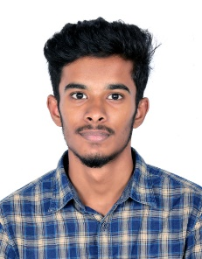

**Karthik Chockalingam V** (20MSS017), Fourth Year

M.Sc. Software Systems,

Batch (2020-2025), PSG College of Arts & Science, Coimbatore.